**CSE 6032 Computer Networks Prj2–Part1 Report**

Student-Id and Name:1800003383-Pelin İNAN

1. **Host Network Settings**

Paste here after “**Network Connection Details**” of the network adapter connecting your Host to the **Home Network.**

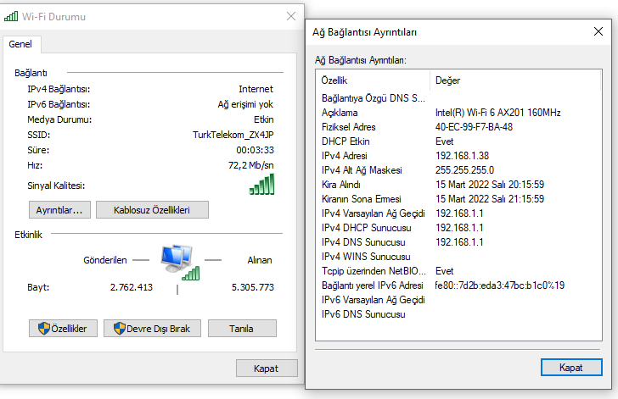

1. **Analysis of the DNS Protocol**
   1. Answer the following question using L2 frames1 captured in **Section A.3**.

|  |  |  |  |  |
| --- | --- | --- | --- | --- |
| **Question** | | | | |
| **Identify** in the **“a3.pcapng**” file **ARP** **query/reply** pair that retrieved the **MAC @** of the **default gateway**; and paste their **Packet Summary Report** here after. | | | | |
|  | | | |
| **Question** | **Answer** | | |
| Write the **name of the protocols** that are **embedded** in a **L2 frame** carrying a **DNS query** | DNS | | |
| What is the **next-hop** of a **L2 frame** carrying a **DNS query?** |  | | |
| What is the **destination IP@** of the datagram embedded in a **L2 frame** carrying a **DNS query?** | 40:ec:99:f7:ba:48 | | |
| What is the **source IP@** of the datagram embedded in a **L2 frame** carrying a **DNS reply?** | 08:26:97:bb:42:12 | | |
| What is the **destination** **socket-id** (port number + Protocol name) of the segment embedded in a **L2 frame** carrying a **DNS query?** | | Destination Port:53  192.168.1.1 |
| What is the **source** **socket-id** (port number + Protocol name) of the segment embedded in a **L2 frame** carrying a **DNS query?** | | Source ort: 57574  192.168.1.38 |

* 1. Given the FQDN of the default root server displayed in **Section A.2/iv**, find, and write its **IPv4@**; the name of the organization that controls this root server. Explain briefly how you identified this organization?

151.101.1.67 A. Wireshark only got this IPV4 address when I was writing the code. However, command prompt gave me 4 IPv4 outputs.

* 1. Answer the following question using yours test results in **Sections A.3 – A.5**.

|  |  |
| --- | --- |
| **Question** | |
| **Identify** in the **“a3.pcapng**” file the **reverse** **query/reply** pair that **nslookup** used to retrieve the **FQDN** of the **default DNS server**; and paste their **Packet Summary Report** here after. | |
|  |
| How **nslookup** managed to display the FQDN of the IKU’s DNS server in **Section A.5**? |
|  |

1. **BONUS QUESTIONS**

Answer the following questions using the knowhow you acquired throughout this project.

|  |  |
| --- | --- |
| **Question** | **Answer** |
| What are the **FQDN** and **IPv.4 @** of one of the **Authoritative DNS** servers for the “**tr.**” Domain? |  |
| Explain briefly how you obtained the **FQDN** of the **Authoritative DNS** servers for the “**tr.**” domain | SOA |
| What are the **FQDN** and **IPv.4 @** of one of the **Authoritative DNS** server for the “**edu.tr.**” domain? | NS |
| What are the **FQDN** and **IPv.4 @** of one of the **Internet root server** located in Ankara? Who is running it? |  |